- Create a simple Streamlit app in a file called app.py that displays your favorite IPL team's name and logo, then deploy it to Streamlit Cloud and share your live app link.

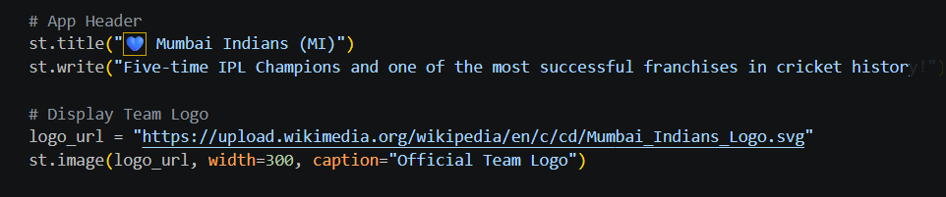

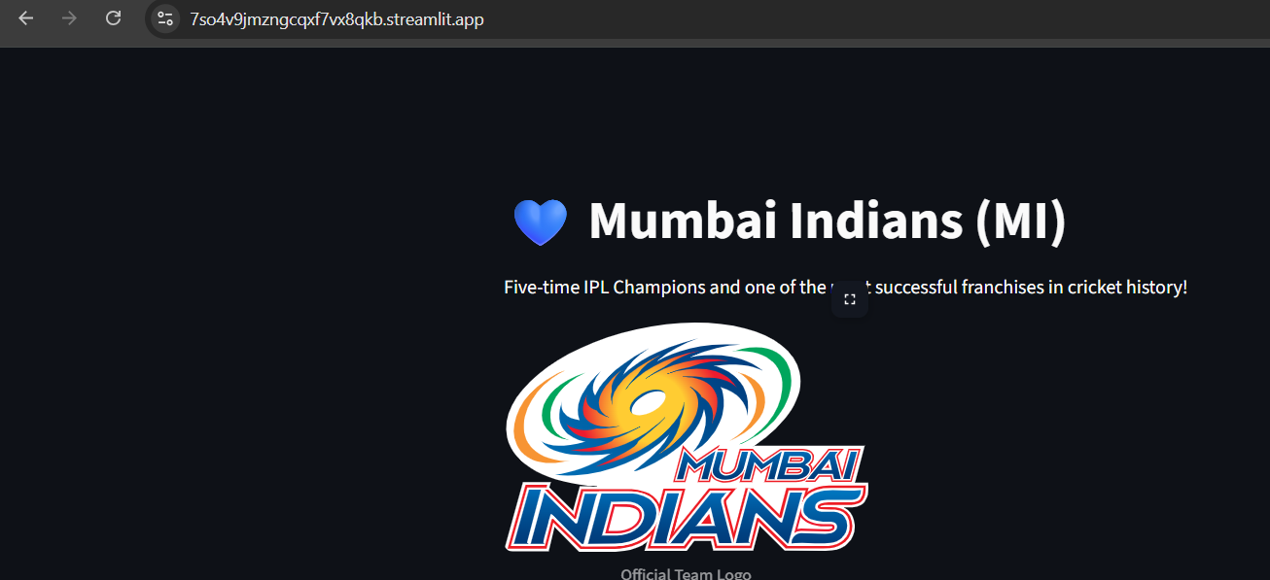

===========================================================================

- Build a mini movie recommendation app using Streamlit that shows 5 trending Bollywood movies (hardcoded list) with their posters and a short description, then upload your project files to Hugging Face Spaces and deploy your app online. Use st.image() and st.write() in Streamlit to display images and text.
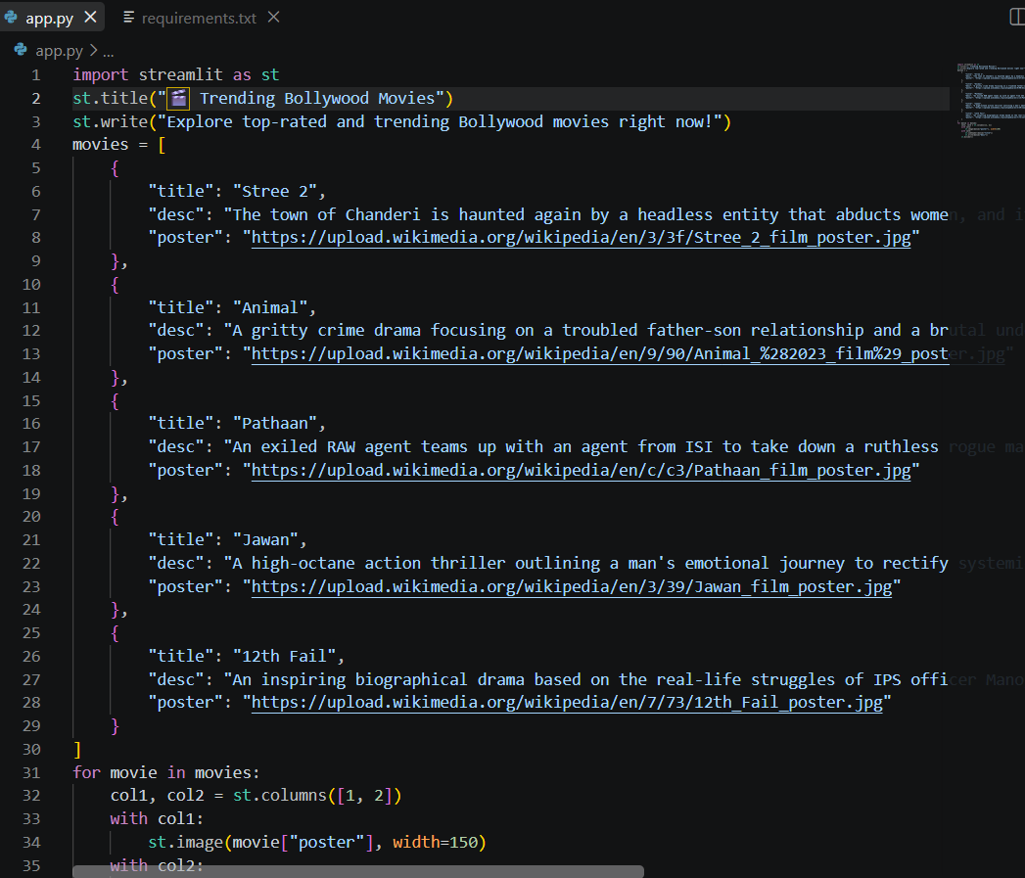

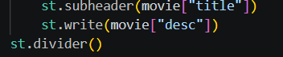

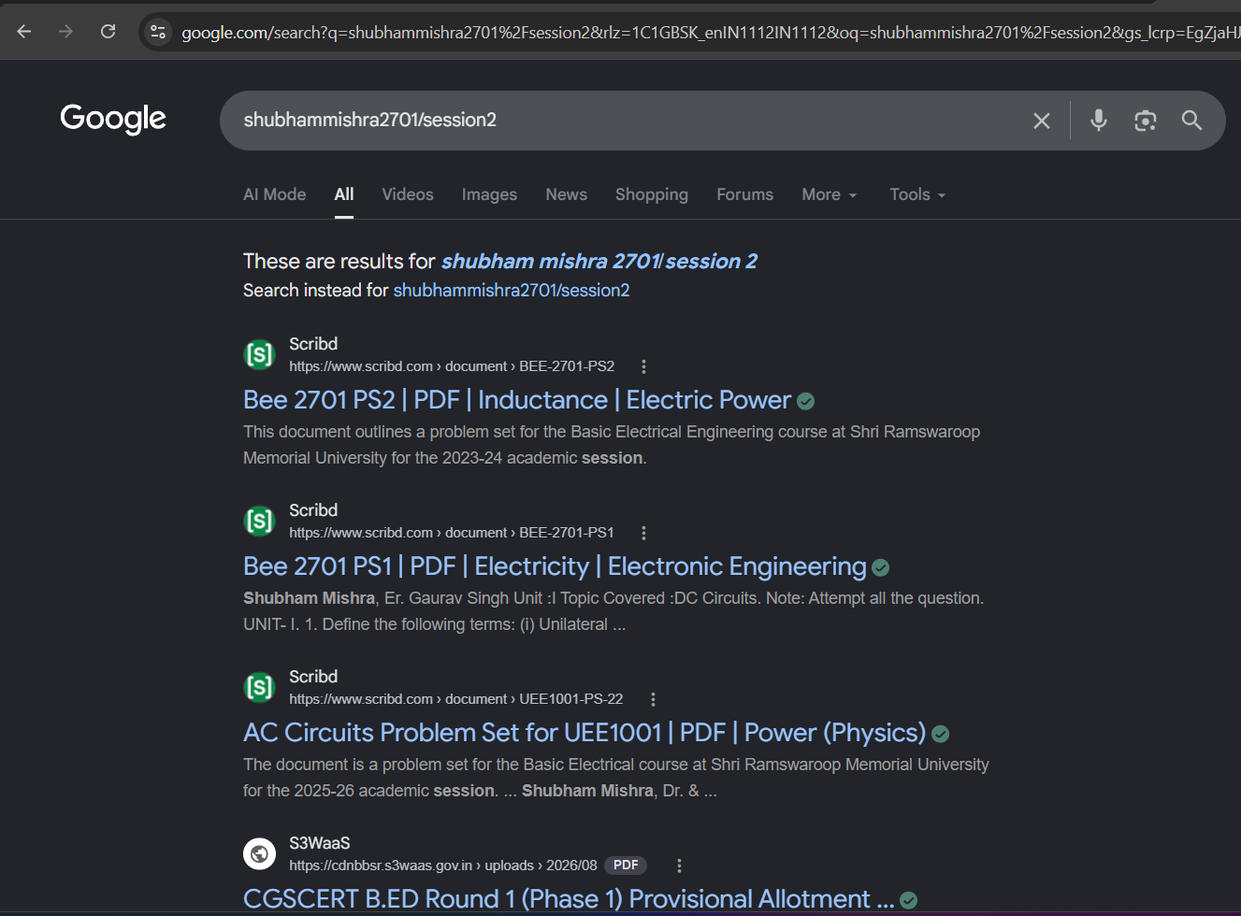

===========================================================================

- Create a requirements.txt file listing all Python packages your app needs (for example: streamlit, pandas, numpy), upload it with your project, and explain in one sentence why requirements.txt is important for cloud deployment.
A requirements.txt file is essential for cloud deployment because it informs the remote server which Python libraries and exact versions must be automatically installed for your application to run without missing module errors.

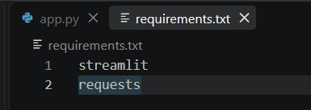===========================================================================

- Simulate a basic deployment issue: remove 'streamlit' from your requirements.txt, try to deploy your app on Streamlit Cloud, and note the error message you receive. Then, fix the issue and redeploy successfully. Take a screenshot of the error and the fixed deployment page.

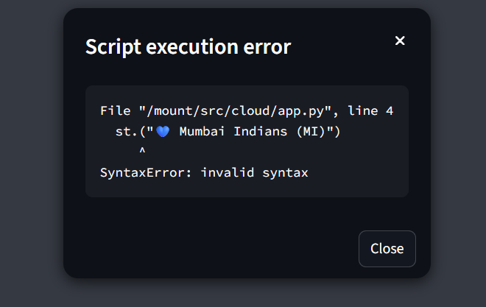

- After deploying your app online, share your live project link with a friend and ask them to test it on their phone. Write down one feedback point they give and how you would improve your app based on it.
User Testing & Feedback Improvement
- Friend's Feedback: "The movie posters look great, but on my mobile phone screen, the description text feels a bit too cramped right beside the small poster images."
- Improvement Plan: Refactor the layout logic using responsive containers or conditional display blocks (e.g., stacking images vertically on smaller viewports or adjusting column widths with st.columns([1, 3])) to improve readability and mobile user experience.

